Battlezone Redux User Manual

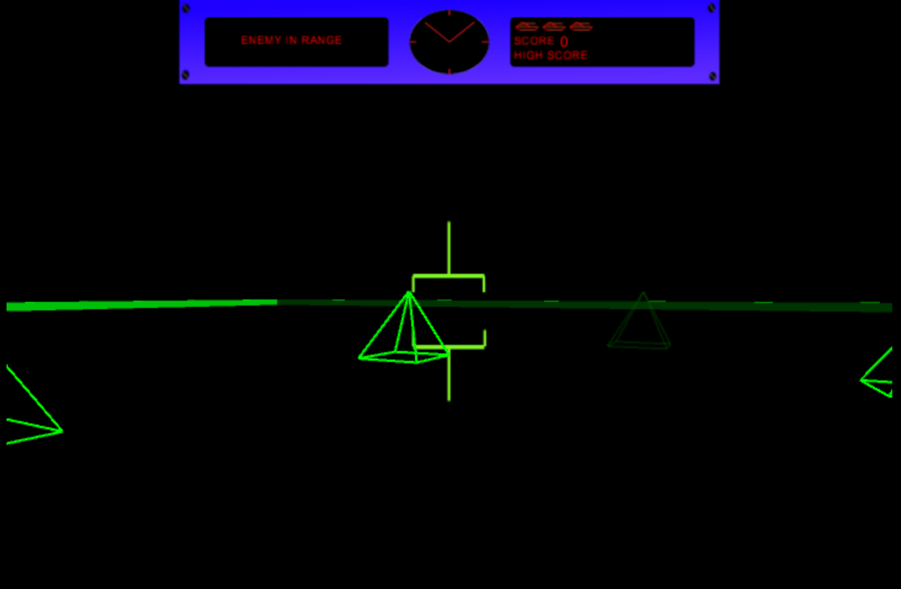

Table of Contents

Overview 3

Installing Battlezone Redux 4

Running Battlezone Redux 4

Playing Battlezone Redux 5

Exiting Battlezone Redux 5

Credits 6

# Overview

Battlezone is a classic arcade game produced by Atari in 1980. This popular classic had the player take control of their very own tank, which they commanded through a dangerous battlefield, destroying enemy tanks and avoiding threats and dodging enemy fire. The game, on release, was widely successful, and due to its use of vertex graphics, was also considered one of the first examples of virtual reality in computer games.

Battlezone Redux hopes to revisit the Atari classic and give it new life, by bringing it to a new audience. The game has been built from the ground up, and allow a whole new generation to enjoy this retro hit!

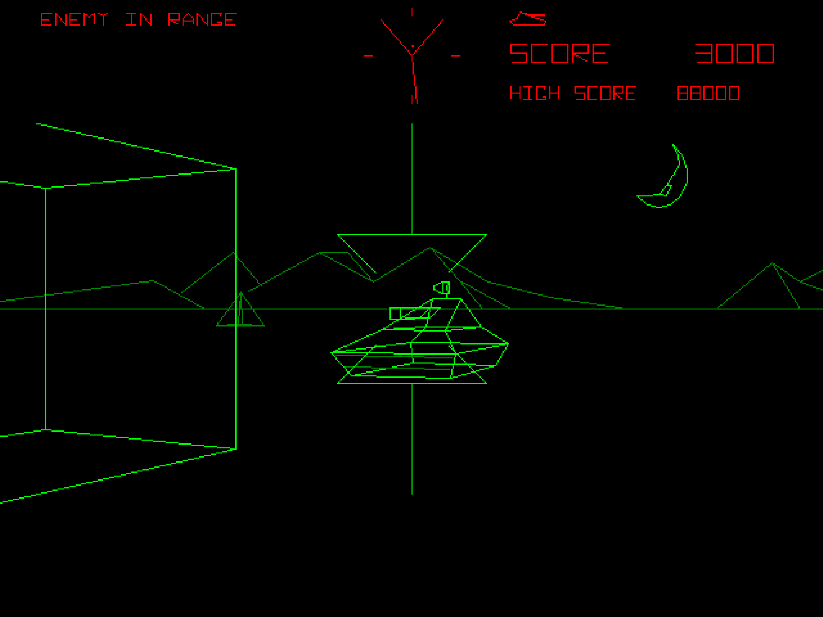

# Installing Battlezone Redux

Simply extract the contents of the BZredux.zip file to the location of your choice. BZredux.exe will automatically be placed there.

# Running Battlezone Redux

To run and play Battlezone Redux, simply double-click BZredux.exe. This screen will appear:

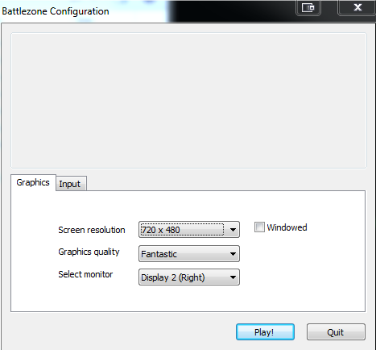

Simply hit play and you will be playing Battlezone Redux.

Battlezone Redux runs best at 720 x 480 for an authentic experience.

# Playing Battlezone Redux



When you launch Battlezone Redux, you will be greeted by the game screen.

Your Radar is at the top of the screen, along with your vision cone. This tells you where enemies are appearing. Enemies will try to destroy you. Do not let them!

An information readout on the top-left of the screen will inform you if an enemy is nearby. Be quick and take them out!

Use the Arrow Keys to move forward and back, and to turn left and right. Press spacebar to shoot and destroy enemy targets.

Your lives, score and the high score are displayed in the top right of the screen. You start the game with 3 lives, and when you run out, your game is over! Each enemy destroyed is worth 100 points. Try to beat the high score, and be the coolest among your friends!

# Exiting Battlezone Redux

Wait, what? You want to exit the best game ever? Well ok then. Simply press Escape to close the application.

# Credits

Team Fantastic Five

Chris Mahon

Christopher Jerrard-Dunne

Jake Mulholland

Jun Hee Jang

Konrad Jedrol